**Amazon AWS**

***Workshop 1:* Create and connect to an instance**

**Step 1:** build a network (VPC)

click on AWS Console

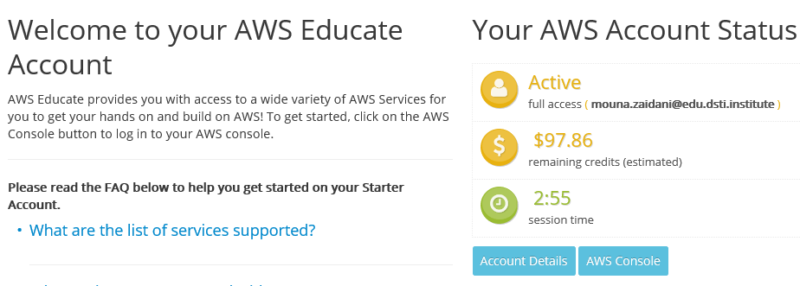



We land on AWS management Console

